Data Preparation
- Code file is – Link to code file
- Entire dataset had 105K series
- Then I removed all the series which had no sales on or before August 1st, 2025 because I plan to use August 1st, 2025 to Dec 31st, 2025 as the validation set.
- Then I checked the proportion of non-zero rows for each series and I found that 75th percentile of descriptive statistics is as below –
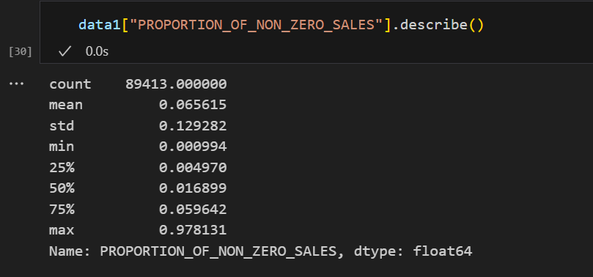
- Then I filtered out all the series which have proportion of non-zero sales less than 0.059642
- I got 22K series. Image below captures how much was actual sales during Sep-Dec (because that is the most critical time period and how much was the sales captured by these series)

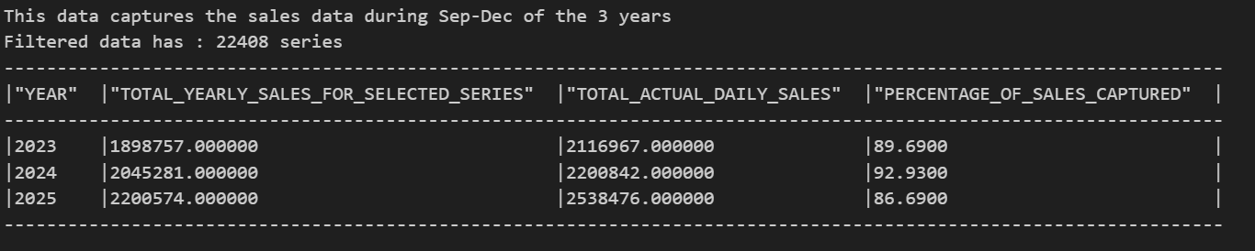

- We will call these as Series A saved in the snowflake table – MOP_DATABASE.SOQ.SERIES_A_FOR_DAILY_FORECASTING

- We will call these as Series B saved in the snowflake table – MOP_DATABASE.SOQ.SERIES_B_FOR_DAILY_FORECASTING

- Shape of the final dataset is - (22542448, 87)

- Snowflake table having the final data for model training and prediction is - MOP_DATABASE.SOQ.DAILY_FORECASTING_DATA_FOR_MODELLING_TFT_APR_23_TO_DEC_26_SERIES_A

